Import Data Using Transform Maps (Spreadsheet)
Project Testing Phase
Date | 30 SEPTEMBER 2026
Team ID | 6ab277cdba33564c8ba151a5
Project Name | Import Data using Transform Maps (Spreadsheet)
Maximum Marks | 4 Marks

The data import process was tested in ServiceNow using a spreadsheet and a Transform Map. The spreadsheet data was loaded into ServiceNow, source fields were mapped to the corresponding target fields, and the transformation was executed. The resulting records were then verified in the target table.

1. Prepare the Spreadsheet
The employee data was prepared in a spreadsheet with the required fields and records. The spreadsheet was used as the source for the ServiceNow data import process.
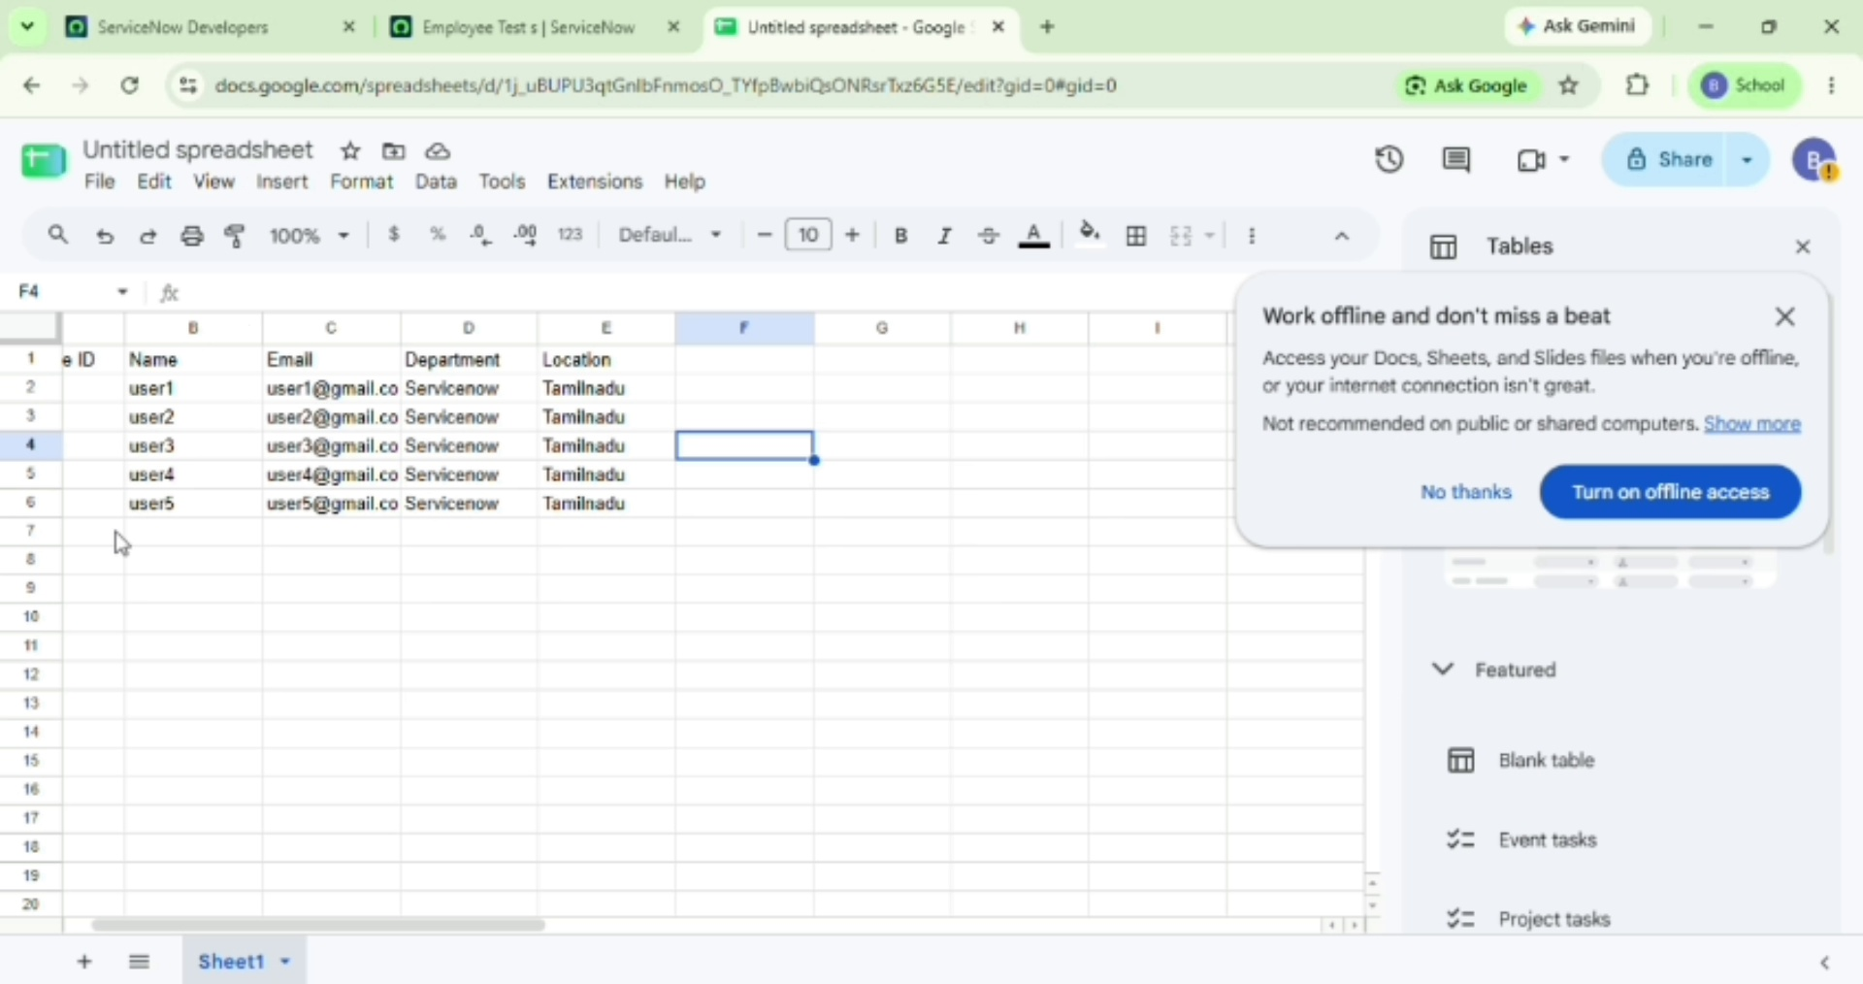
Screenshot – Prepare the Spreadsheet

2. Load the Spreadsheet into ServiceNow
The spreadsheet was uploaded into ServiceNow through the import process. ServiceNow created/used the import-set data as the source for the transformation.
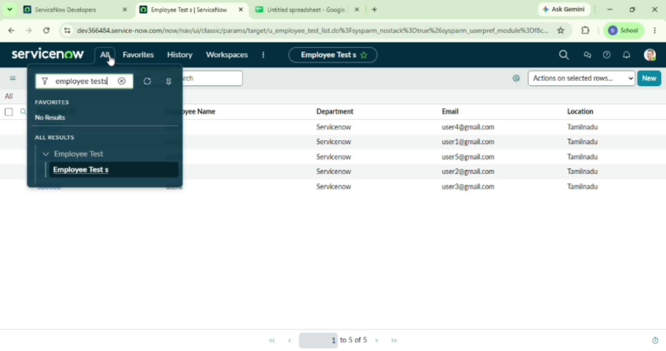
Screenshot – Load the Spreadsheet into ServiceNow

3. Configure the Transform Map
A Transform Map was configured to transfer data from the imported source table to the required target table. The source and target tables were selected for the transformation.
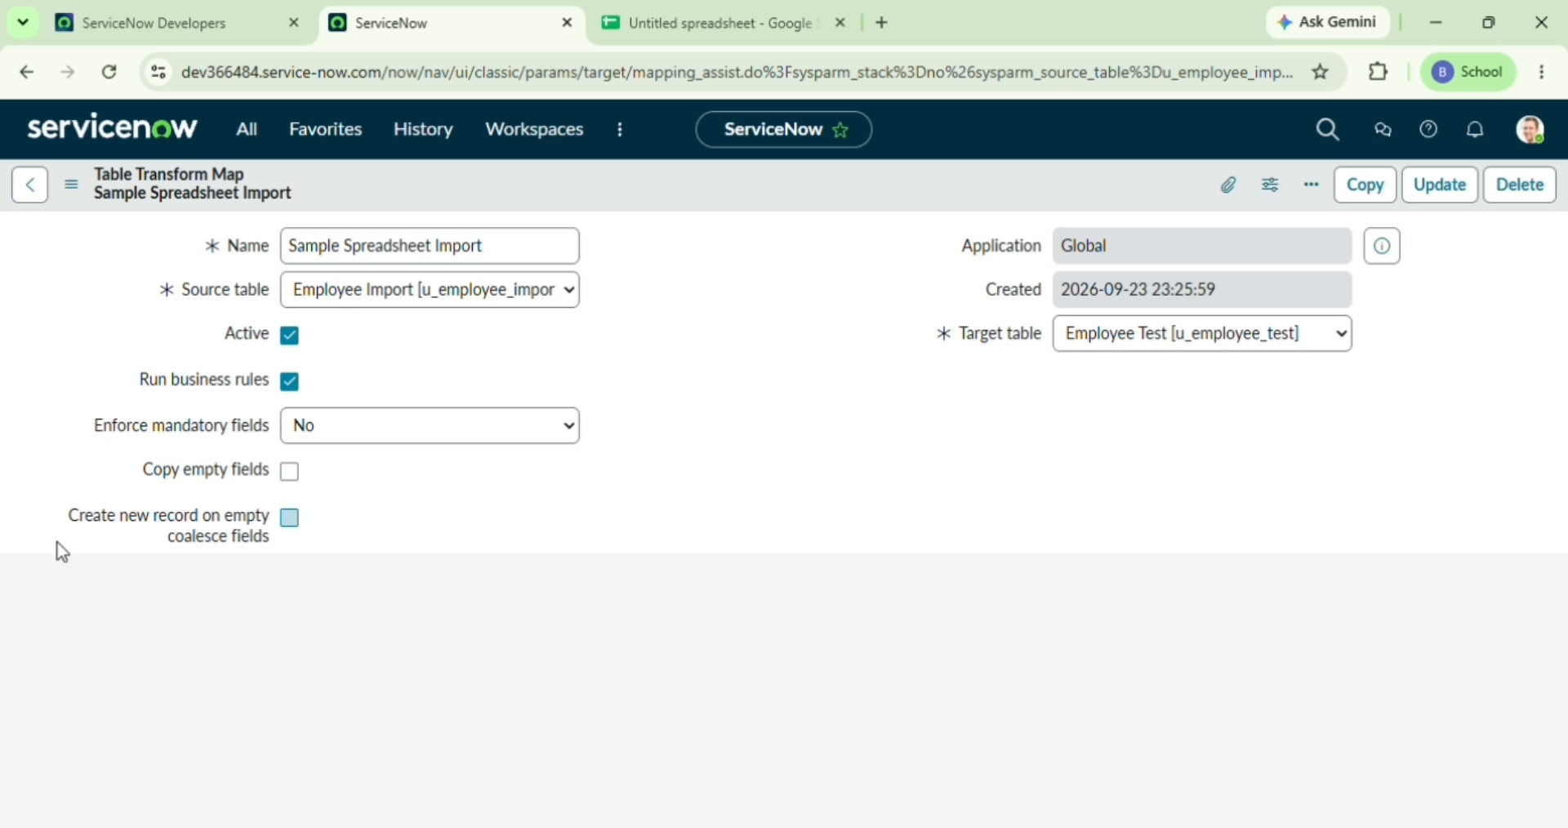
Screenshot – Configure the Transform Map

4. Map the Fields
The source fields from the imported spreadsheet were mapped to the corresponding fields in the target table. This ensured that each value was transferred to the correct field.
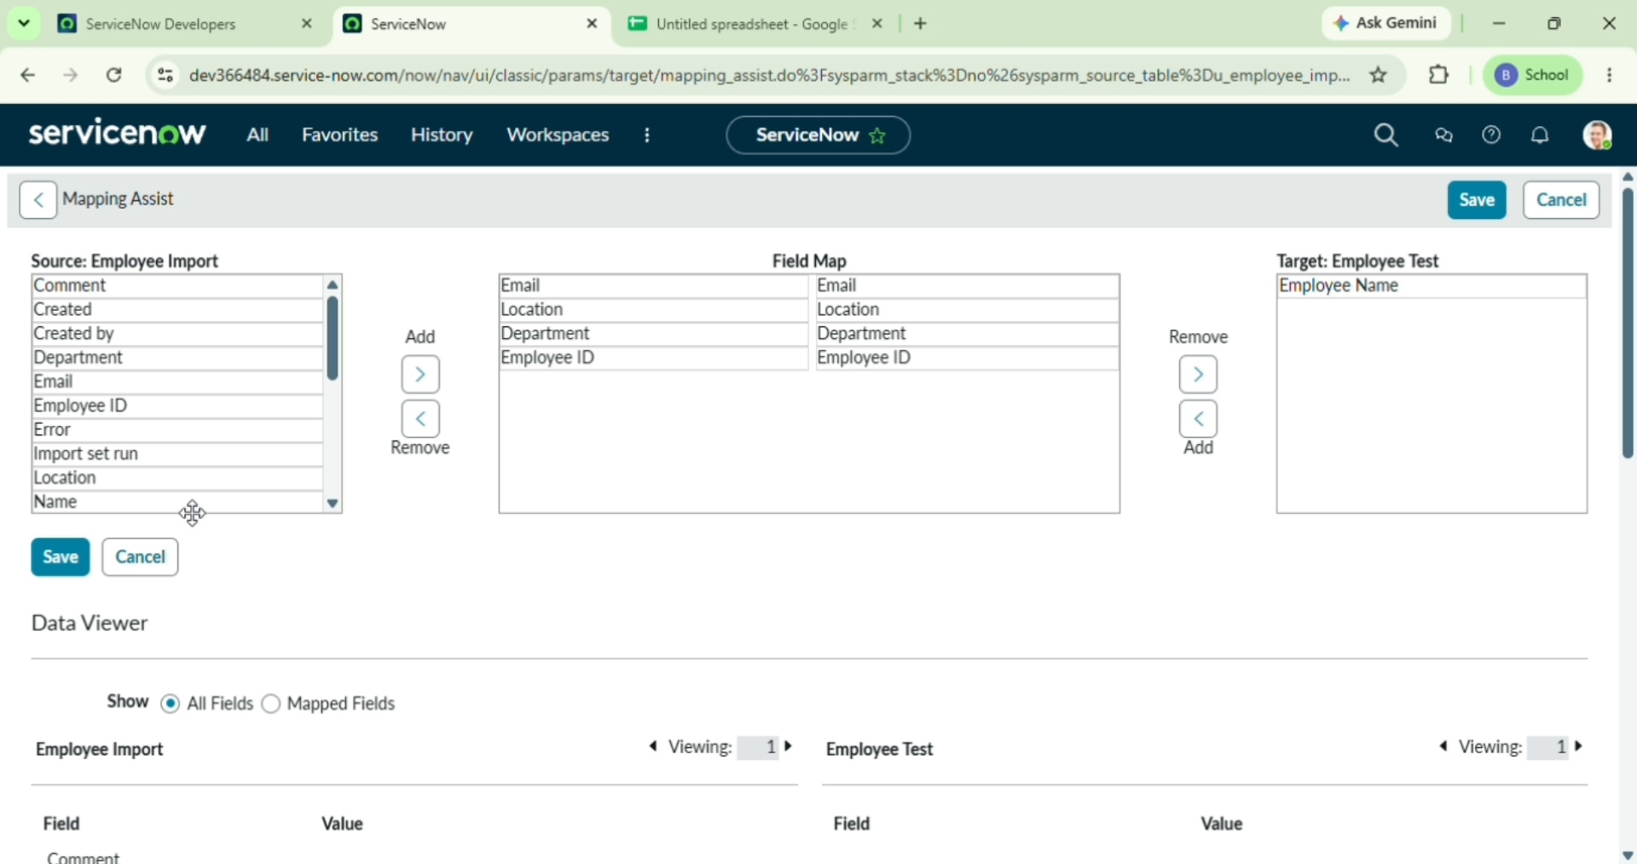
Screenshot – Map the Fields

5. Execute the Transformation
The Transform Map was run to transform the imported spreadsheet data and create/update records in the target table.
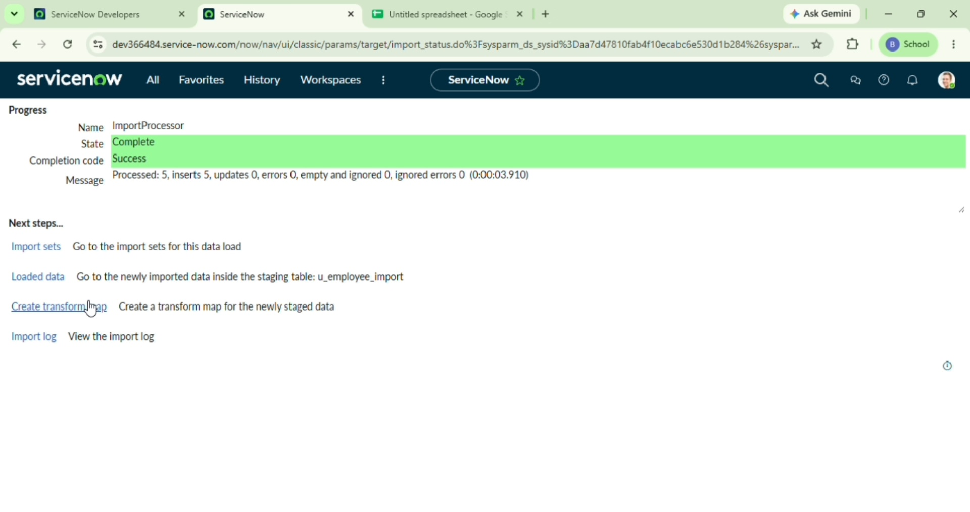
Screenshot – Execute the Transformation

6. Verify the Imported Records
The target records were checked after the transformation. The imported employee information was displayed in the target table, confirming that the data was transferred successfully.
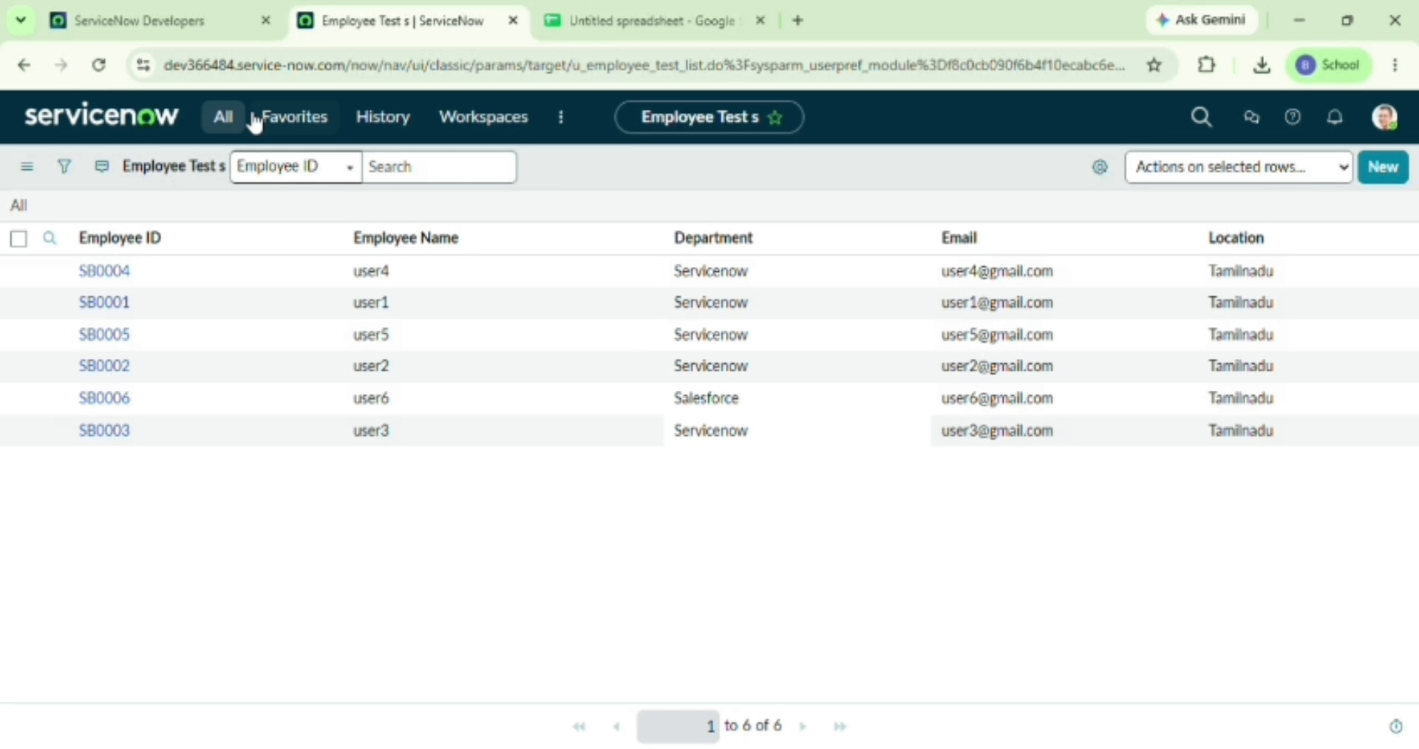
Screenshot – Verify the Imported Records

Testing Result
Result: The spreadsheet data was successfully imported into ServiceNow using the Transform Map, and the transformed records were verified in the target table.
Status: Pass

